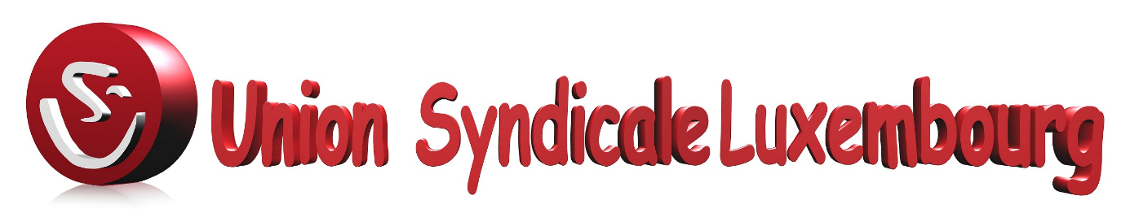

Luxembourg, 4 october 2018.

Dear Ms Souka,

Union Syndicale Luxembourg thanks you for your note, explaining that, upon your proposition, the PMO has denounced the Convention with L’Association des Médecins et Médecins Dentistes du Grand-Duché de Luxembourg. Consequently, as per 1 October 2018 medical doctors and dentists will no longer be allowed to add 15% to the CNS tariffs as published in the “livre bleu”.
As this initiative must be placed against the context of the massive subscription of colleagues to Petition 765 before the Chambre des Deputés du Grand Duché de Luxembourg, we wish to congratulate you for the cooperation between the Heads of Administration of EU institutions in Luxembourg (CALUX) which enabled the denunciation. The CALUX seems to have followed the logic that this 15% has no economical ground. Bravo for the excellent result achieved!
We also wish to take this opportunity to draw your attention to the other convention, namely with the hospitals. As you are undoubtedly aware of, some legal developments after the convention’s signature give raise to arguments which question the legality of medical invoices overcharging in Luxembourg under it. It is not only the European Court of Justice’ jurisprudence as e.g. in the Ferlini case but also Directive 2011/24/EU Health Insurance which bring important elements to the table. Indeed, you may recall that in the Ferlini ruling the ECJ considered EU Staff as migrant workers – which should thus be protected from discrimination on the basis of nationality and having patient rights in cross-border health care.
However, not only are there legal impediments, the Convention has also been incorrectly executed and not been respectfully adhered to.
To start with, Article 4 calls for the establishment of a “commission technique” to regularly analyse the “coût de revient net”, to review the classification of tariffs applied by hospitals and to assess, more generally, the modus operandi of the convention. As you know, no such a committee was installed before 25 January 2018, and its only meeting was characterised, interestingly, by a failure of the hospitals to cooperate. It implies that hospitals have, until to date, set their tariffs applicable to EU civil servants and EIB Staff in a unilateral way, which would arguably run counter to the Ferlini ruling and EU law mentioned above. We believe that there are simply no results from that commission that can be reported – except for its failure to fulfil its task.
There is more. The list of medical practices falling under each “Entité Fonctionelle” (OPx, CC, IMX, PCx etc), that is their “susbdivision”, is established under Annex 3 of the Convention. That Annex foresees a certain mapping of medical practices with the respective “Entités fonctionelles”. If we are not mistaken, these subdivisions have been changed over time, despite Article 3 “structure des tarifs” stipulating that such changes can only be done in common agreement of all signatories to the Convention – quod non. It adds to the argument that the hospitals have unilaterally set discriminating tariffs for EU Civil Services and EIB Staff in Luxembourg. Consequently the tacit renewal over the last decades of this Convention has undisputedly resulted in undue costs having been inputted to the RCAM and the Caisse de maladie of the EIB, and this with knowledge of the Pay Master’s Office (PMO) without, however, due verifications on the side of the PMO on the correct implementation of the contractual terms and conditions of the Convention, and to act diligently upon such abuses.
As a result thereof, you may have seen, on the political field, the conclusions of the European Parliament to the 2016 discharge of the annual EU budget that question the legality of the practice of overcharging in Luxembourg in view of this and call for taking stock of the total cost of the overcharged amounts and actions against Luxembourg. The Commission, notably Commissioner Oettinger, has meanwhile also initiated discussions with the Netherlands on the same subject retaking the same argumentation on non-compliance with existing jurisprudence and EU law.
However, and in concluding, we wish to come back to the basis for the denunciation of the convention with the AMMD to eliminate the 15% overcharging on doctors’ fees, and bring to your attention that exactly the same overcharging is in place

for the hospital fees. Indeed, Article 1(5) of the convention with the Hospitals foresees in 15% being applied on the tariff which should reflect the so-called “coût de revient net”.
Surely, if the PMO and, more generally, all Administrators in the CALUX considered that there is no economic justification for doctors to add 15% to their fees, consistency would have it that the PMO and the CALUX would have to agree that the application of this coefficient on the revenues for the hospital also has to be firmly rejected, and that the convention with the hospitals thus merits to be denounced at least on the very same grounds as the one with the AMMD has been if not for all other reasons we set out above.
As the invoicing impacts on the budget of international institutions (notably the Commission’s and EIB’s Health Scheme), please do take note of Article 496-4 of the Code penal of Luxembourg relative to “sur le détournement d’un avantage légalement obtenu en réalisant une diminution des ressources du budget d’une institution internationale”.
For all these reasons, we kindly and respectfully request you to plead before the CALUX and before your respective hierarchies that the Convention with the Hospitals is also urgently denounced. The deadline to do so would be 2 months before 31 December by registered letter, that is Tuesday 30 October 2018 at the latest.
To our best of knowledge, the fear of a “legal gap” following such a denunciation seems unwarranted. Indeed, the hospitals have already in place a system of prices reflecting the “coût de revient” that the hospitals apply both for cross-border patients who are accepted based on the European Health Insurance card while being faced with hospitalisation in Luxembourg, and to invoice the hospital costs for patients falling under the CNS. Nothing would thus impede on an equal treatment of EU civil servants and EIB Staff with patients falling under those systems.
Of course, subsequently negotiations can be accepted, should the hospitals or the government propose so, to possibly come to a new and fairer convention, fully in line with the EU legislation and jurisprudence.
We are looking forward to receiving your comments, and hope for your support.
Please be assured, dear Ms. Souka, of our highest esteem,
Miguel Vicente Nunez – USL President Patrick Vanhoudt – Petitioner and EIB Staff Representative
(signé) (signé)
Copy : Ms. Gaffey – PMO
Mr. Oettinger – Commissaire CCE
CALUX
Secrétaires Généraux Institutions UE Luxembourg
Personnel BEI- Institutions UE Luxembourg

227, VAL DES BONS-MALADES - L2121 LUXEMBOURG / TELEPHONE : 43 25 79 / TELEFAX : 43 29 64
unionsl@pt.lu - www.uslux.eu

